Copperhead Ag Furrow Cruiser Sale

From now Until Jan 31st 2021, Copperhead Ag Furrow Cruiser inserts and complete wheels will be on sale. Inserts which are 2 inserts per row will be $115 (normally $130). Completes and Cast wheels will remain the same price.

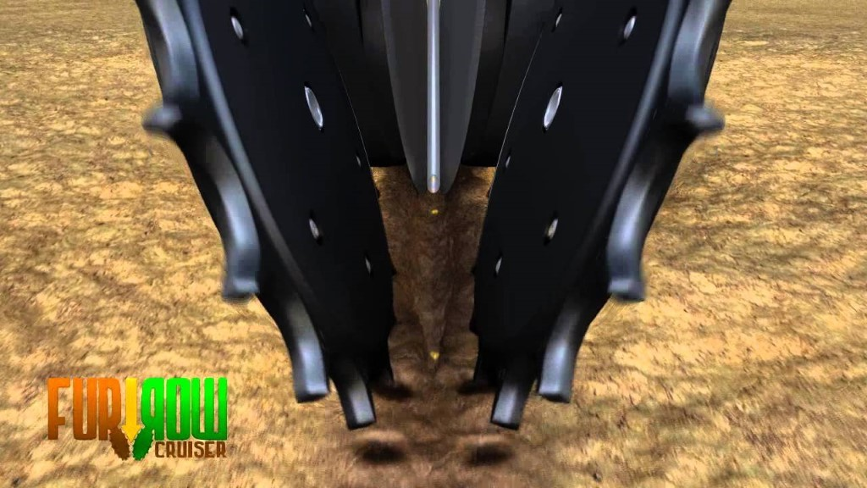

Copperhead Ag Furrow Cruiser closing wheels are spiked closing wheels that fits into your existing closing wheels’ hubs on many planters. They allow young roots to penetrate sidewalls by eliminating sidewall compaction on BOTH sides of the furrow. They also improve seed to soil contact while preventing the furrow from reopening. These closing wheels work in virtually every soil condition, tillage practice, and are most effective in saturated soils. The angular design of the teeth prevents clogging problems that some other closing wheels may have. The expected life span is 500-600 acres per row which means a 12 row planter has a 6000-8000 acre life span. Guaranteed throughout life against breaking and cracking.

Many unaffiliated studies show a consistent 3.8 bu/ac advantage over 2 rubber wheels on corn and 1.7 bu/ac on soybeans. This is over multiple tillage practices, areas, soil types and field conditions I understand. Still from what I have seen and heard the ROI on these closing wheels is very quick especially in no till, or minimum till conditions as well as any non-ideal wetter conditions.
CORN
- Let’s assume a conservative 1.5 bu/ac advantage using Furrow Cruisers over a 2 rubber wheel system at $4.00 corn price on 500 acres of corn.
- $115 per inserts per row X 16 row planter= $1,840 cost
- 1.5bu/ac X $4.00 corn= $6 per acre
- $6.00 per acre X 500 acres= $3,000
- Would take around 300 acres of corn over a 16 row planter to pay for itself.
SOYBEANS
- Let’s assume a conservative 0.5 bu/ac advantage using Furrow Cruisers over a 2 rubber wheel system at $12.00 soybean price on 500 acres of soybeans.
- $115 per inserts per row X 16 row planter= $1,840 cost
- 0.5bu/ac X $12.00 soybeans= $6 per acre
- $6.00 per acre X 500 acres= $3,000
- Would take around 300 acres of soybeans over a 16 row planter to pay for itself.
Again adverse planting conditions generally increase these figures, perfect ideal conditions may not be an advantage over rubber wheels but will not hurt you either.

Also attached is an independent study from a grower in 2018.

If you have any questions, contact me at (217) 670-4435 or the main office at (309) 527-6455

Precision Planting SmartFirmer

SmartFirmer is an innovative product that allows you to sense your soil and furrow on the fly. It will sense and map your soil moisture, soil temperature, furrow uniformity, in furrow crop residue, and organic matter on rows you have a SmartFimer installed. SmartFirmer can also give you the ability to make automatic population adjustments based off of organic matter.

Highlights of SmartFirmer:

· Soil moisture is a critical component for seed germination and uniform plant emergence, and ultimately crop yield. SmartFirmer gives you row-by-row visibility to soil moisture in the seed furrow, allowing you to choose the right planting depth as soil conditions change.
· Sufficient soil temperature is a critical component for rapid seed germination. As an example, the time for a corn seed to germinate will dramatically increase as temperatures drop below 50 degrees Fahrenheit. SmartFirmer gives you row-by-row visibility of soil temperature in the seed furrow, ensuring that you are planting in favorable conditions.
· A consistent environment is essential for uniform seed germination and plant growth. SmartFirmer identifies any irregularities along the furrow, such as soil clods, air space and dry soil falling from the surface, so that you can have the insight to correct row unit performance and solve these yield-robbing problems.
· In-furrow crop residue has well-known negative impacts on seed germination and growth. SmartFirmer allows you to measure the quantity of in-furrow residue and adjust row cleaners accordingly, thus ensuring residue won’t limit seed moisture uptake or transmit disease.
· In any field, there are multiple yield environments that are determined by soil type, organic matter, topography, drainage and dozens of other attributes. To better manage these yield environments, the SmartFirmer high definition organic matter map is a key input for developing precise prescriptions for planting population, seed hybrid and fertility applications. SmartFirmer can provide automatic, on-the-go control of planting populations or hybrids based on organic matter measurements.

Linco Precision will have 8 SmartFirmers available to purchase or demo on your planter. If wanting to purchase SmartFimer, there are a limited number of units left to purchase from Precision Planting. SmartFimer must utilize the SRM row by row (vDrive/ DeltaForce) architecture and must also use the Keeton quick attach firmer bracket. Contact Andy with questions, or for more details.

Corn Meter Cleaning, Inspection, and Calibration Reminder

Bring your corn meters to our El Paso, or Nokomis locations to get them properly cleaned, inspected and calibrated. Contact me for more details.

The MeterMax Test Stand allows us to get precise seed spacing. Here’s what we do:
· Clean and replace worn parts and properly balance the meter.
· Place a finger pickup or vacuum meter onto the stand.
· Add the specific seed size and weight corn you will be planting if you bring some in.
· Set the Test Stand speed gauge to your planting speed.
· Watch seeds drop into the grated belt and count skips, doubles, or triples.
· Adjust the meter and retest until we’ve eliminated all meter errors.

