Meter Cleaning and Calibrating Early Bird Special

Before you put your planter in the back of the shed, bring your John Deere or Kinze planter meters to our Nokomis location before December 31st, 2020 for cleaning and service. Only $35 per unit which is a $5 savings, repair parts not included.
OUR GUARANTEE: If we can’t show you an improvement in meter performance, your cleaning is on us.
WHEN: NOW through December 31st, 2020
WHERE: 15215 Nokomis Rd, Nokomis IL
Call: Andy at (217) 670-4435

We do between 1,000 and 1,400 meters each season. We have seen anywhere from a 1% to a 62% improvement in meter performance. We almost never see an instance where the procedure doesn’t improve performance on vacuum meters at least 2% and almost always improve performance on finger meters 3-4% with some finger meters a much higher improvement percentage. We do have a guarantee that if we can’t improve the performance, the service is free on that meter.

Assumptions: each 1% improvement in planting accuracy = a 2 bushel increase in yield. Corn price = $3.00. For calculation purposes average meter improvement is figured at 2% improvement. Average individual corn meter in the Midwest plants 100 acres of corn annually

Calculation: 2% increase in accuracy = 4 bu per acre X 100 acres per year per meter X $3.00 per bushel = $1,200 additional income per meter, $35 per meter service cost (does not include any repair parts that may be needed)
$1,200/ $35= 3,428% Return on Investment

Getting your meters, cleaned and calibrated every year is a no brainer!!!

Precision Planting 2020 Precision Decision Summer Programs Ending Soon

Highlights of Precision Planting Programs
- 5% Early Order Discount on any Precision Planting parts through August 30th, 2020. This can be done in conjunction with any of the programs or financing offers. This is a great time to order even any small maintenance parts, keetons, meter parts, cleansweep, speedtube wear parts, ect….
- $200 off per row for 3 products (vDrive, vDrive Insecticide, Deltaforce, or SpeedTube) purchased between June 1, 2020- September 30th, 2020.
- $150 off per row for 2 products (vDrive, vDrive Insecticide, Deltaforce, or SpeedTube) purchased between June 1, 2020- September 30th, 2020.
- $50 off per row for 1 product (vDrive, vDrive Insecticide, Deltaforce, or SpeedTube) purchased between June 1, 2020- September 30th, 2020.
- Purchase a Gen 3 20/20 planter monitor (upgrade or new display purchase) and receive a $1,000 rebate. Rebate applies between the dates of June 1st, 2020 and September 30th, 2020.
- Purchase a Gen 3 20/20 planter monitor (upgrade or new display purchase) and receive a $500 rebate. Rebate applies between the dates of October 4th, 2020 and January 4th, 2021.

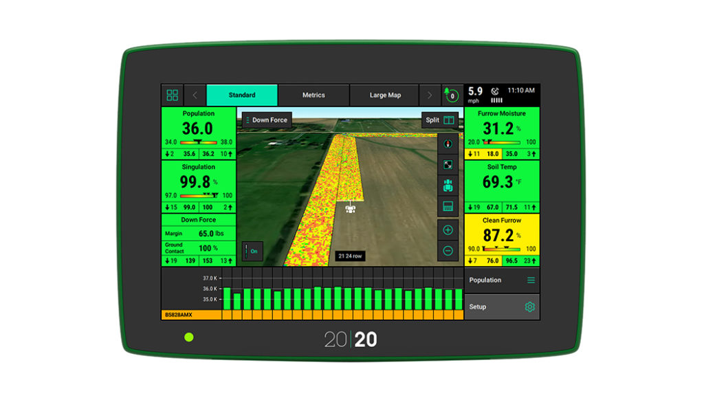

Financing Options Available
- Precision Planting has partnered with Diversified Financial to provide a Discounted 60-month or 36 month Grower Financing offer. The rate is 1.99% 60-months. That rate is effective June 1st, 2020 through July 15th, 2020. After July 15th 2020 a new rate will be released but the lowest rate WILL BE the 1.99%.
- Financing is on orders of $10,000 or more.
- Grower is required to make a down payment of 20% of the product order invoice amount at the time of purchase. The remaining balance is broken into three equal payments for the 36-month financing option and five equal payments for the 60-month option. The 1st grower payment is due 12 months from the date of the signed loan documents; the 2nd grower payment is due in 24 months; and the 3rd grower payment is due in 36 months. For the 60-month financing option, The 1st grower payment is due 12 months from the date of the signed loan documents; the 2nd grower payment is due in 24 months; the 3rd grower payment is due in 36 months; the 4th grower payment is due in 48 months; and the 5th grower payment is due in 60 months.

Highlights of Linco Precision/ Precision Planting Programs
- Trade in programs available for trading out of a Gen 1 20/20 into a Gen 2 20/20 or Gen 3 20/20 display. We will offer $400 for a Gen 1 20/20 display towards purchase of a Gen 2 or 3, will offer $75 for a Gen 1 Cab Control Module Switch Box and $75 for a Fieldview Module and cable. The Gen 1 trade in cannot be a hardware version 0 display and must be a working unit. We will offer $1,400 for a Used Gen 2 display in on a Gen 3 display and $300 for a Gen 2 Cab Control Module.
- Trade in programs available on certain parts possibly removed from the planter such as Rowflow, or Airforce, RUMS, and Smart connectors….ect. Value will be discuseed on a per situation basis.
- If parts not applicable for trade in, then we will post online on www.lincoprecision.com used parts section (we will just post it for advertisement, we will not be involved in the selling or transferring of the items)
- 20% installation discount if installation is setup and installed before September 30th, 2020
- 5% Early Order Discount on any Precision Planting parts through August 30th, 2020. This can be done in conjunction with any of the programs or financing offers.
- An additional 5% discount if the payment is paid in full at the time of ordering product and can be used in conjunction with any of the programs except for the financing programs with Diversified Financial. The purchase for the additional 5% discount must be a minimum order of $12,500 in Precision Planting parts.

Copperhead Ag Furrow Cruiser Summer Sale

From now Until Aug 31st, Copperhead Ag Furrow Cruiser inserts and complete wheels will be on sale for the summer discount program. Inserts which are 2 inserts per row will be $111 (normally $130) and the complete wheels which are also 2 wheels per row will be $187 per row (normally $210 per row). There will be free shipping as well.

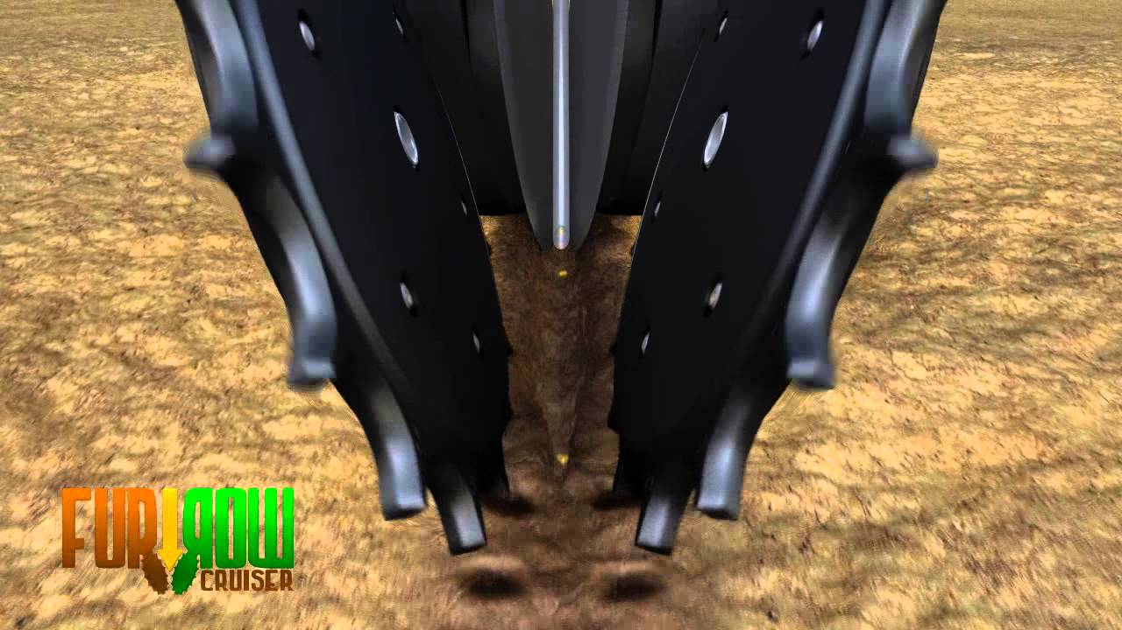

Copperhead Ag Furrow Cruiser closing wheels are spiked closing wheels that fits into your existing closing wheels hubs on many planters. They allow young roots to penetrate sidewalls by eliminating sidewall compaction on BOTH sides of the furrow. They also improve seed to soil contact while preventing the furrow from reopening. These closing wheels work in virtually every soil condition, tillage practice, and are most effective in saturated soils. The angular design of the teeth prevents clogging problems that some other closing wheels may have.

